Config-Driven SEIR Epidemic Simulation Dashboard with Multi-Run Uncertainty Bands and Scenario Comparison

1st Ivo Teovski - Sardzovski
School of Computer Science and Information Technology
University American College Skopje
Skopje, R. N. Macedonia
ivosardzovski@hotmail.com
4th Viktor Denkovski
School of Computer Science and Information Technology
University American College Skopje
Skopje, R. N. Macedonia
viktor.denkovski@uacs.edu.mk
2nd Konstantin Pandilovski
School of Computer Science and Information Technology
University American College Skopje
Skopje, R. N. Macedonia
pandilovskikonstantin@gmail.com
3rd Marija Stankova Medarovska
School of Computer Science and Information Technology
University American College Skopje
Skopje, R. N. Macedonia
marija.s.medarovska@uacs.edu.mk

Abstract—This paper presents a modular epidemic simulation project built for iterative extension and reproducible experimentation. At its core is a config-driven SEIR engine that models’ infection pressure as a function of the current infected share (I/N), supports interventions (lockdown via transmission reduction and vaccination via daily immunization), and produces day-level state trajectories. To quantify uncertainty, the system runs multiple stochastic realizations under identical parameters but different seeds, then aggregates results into mean curves and quantile bands (e.g., 10th–90th percentiles). A lightweight FastAPI backend exposes endpoints for single runs, multi-run bands, and scenario comparison. A React dashboard consumes these APIs and visualizes the infected mean with an uncertainty band and side-by-side scenario comparison (A vs. B) using preset intervention policies. The design separates the simulation engine from the UI, enabling future scaling to larger populations and additional compartments or policies without rewrites.
Keywords—SEIR; epidemic simulation; stochastic runs; uncertainty quantiles; interventions; FastAPI; React; dashboards

Introduction
Categorized epidemic models serve as fundamental tools for understanding the dynamics of infectious diseases, supporting epidemiology in theory and practical decision-making for public health. The Susceptible Exposed Infection Recovered (SEIR) framework widens the basis of the SIR model by modeling the incubation period, which makes it adequate for influenza- and COVID-19-like diseases where the infection is not temporarily present [1, 2]. Aside from their simplicity in concept, SEIR-based models, with their transparency and extensibility, represent the center of forecasting epidemics, running simulations for education, and intervention analysis [3].
Model-based epidemic simulators are useful for rapid what-if analysis, teaching, and policy exploration [4]. However, many student prototypes become hard to extend once new features are requested (larger populations, new compartments, or additional interventions) [5].
This study focuses on an upgrade-friendly architecture: (1) a simulation engine whose behavior is entirely driven by a single configuration object, (2) reproducible stochastic runs via explicit random seeds, and (3) a clean separation between computation and visualization through an HTTP API. In addition to producing a single trajectory, the system supports multi-run aggregation to communicate uncertainty using quantile bands rather than a single deterministic curve.
This study was divided into six sections, in which section one introduces the focus of this research, and section two presents similar related work on the topic at hand. Section three describes the materials and methods used to conduct this research project. Section four showcases the results of this study, in section five, the results are discussed, and finally, section six concludes this paper.

Related work
The research field of epidemic modeling has a broad body of literature that involves the application of compartmental models, such as the standard SEIR model proposed in [6], where individuals within the simulated populations belong to groups of SEIR. The aforementioned models were also extended to account for stochastic simulations and interventions in order to better represent real-life uncertainties. Important contributions in the domain of epidemiology can be found in [7, 8].
Modern systems such as Covasim [9] apply agent-based simulation, calibrated to the real world, in order to perform complex experiments related to epidemics. Unlike the latter systems, the proposed project uses a simplified SEIR model with a configurational approach supplemented by stochastic multi-run and uncertainty visualization capabilities.
Furthermore, contemporary realizations are now heavily based on interactive dashboards and API-driven architecture in order to enhance their performance. The employment of FastAPI and React in this realization is consistent with the existing best practices in the development of modular simulation frameworks [10]. One of the essential features of this framework is that it incorporates quantile-based uncertainty intervals and scenarios comparison, thus allowing the user to evaluate variability among several simulations.

Methodology and System Architecture
For research purposes, a simulation engine with a compartmental SEIR model was integrated together with backend API to expose the engine. Default configuration parameters were set, and various experiments were tested.

Simulation Engine
The engine implements a compartmental SEIR model with daily time steps. Infection was driven by infection pressure proportional to the infected fraction (I/N), so transmission scales naturally with population size. Individuals move from Susceptible to Exposed based on this pressure, from Exposed to Infected after an incubation period, and from Infected to Recovered (or Dead) after an infectious period with a configurable mortality rate. Interventions were represented as a list of typed policies in the configuration: lockdown reduces transmission using a beta multiplier over a day range, and vaccination transfers a configurable fraction of Susceptible individuals to Recovered each day after a start day.

Backend API
A FastAPI service exposes the engine without coupling it to any user interface [11]. The main endpoints are:
- /api/simulate/run - for a single trajectory,
- /api/simulate/multi - for multi-run aggregation with uncertainty bands, and
- /api/simulate/compare - for comparing two scenarios (A vs. B) under identical aggregation settings.
Requests accept a JSON configuration, enabling config export/sharing and reproducible execution across machines.

Dashboard Configuration Parameters (Defaults)
Table I presents the default configuration parameters that were set and shown on the main dashboard.

Experiments
The baseline and intervention scenarios using preset configurations: no intervention, lockdown, vaccination, and combined lockdown+vaccination were evaluated. For uncertainty estimation, multiple stochastic runs with the same parameters but different seeds were performed, and the infected count over time was aggregated into a mean curve and a quantile band (e.g., 10th–90th).
- Dashboard Configuration Parameters (Defaults)
Parameter | Meaning | Default
Population | Total population size N | 10000
Days | Simulation horizon (days) | 120
Initial Infected | Initial number in infected compartment I(0) | 10
Beta | Transmission rate (baseline) | 0.35
Incubation Days | Mean incubation duration (E→I) | 3
Infectious Days | Mean infectious duration (I→R) | 7
Mortality Rate | Fraction of infected that transition to D | 0.01
Seed | Random seed for reproducibility | 42
Runs | Number of stochastic runs for aggregation | 30
Band Low/High | Quantile bounds for the uncertainty band | 0.10 / 0.90
The band communicates run-to-run variability and helps compare policies beyond a single lucky/unlucky trajectory.

Results
Scenario comparison (A vs. B) plots the two mean infected curves on a shared timeline, allowing direct inspection of relative peak height and timing. In typical runs, lockdown reduces and delays the peak by decreasing transmission, while vaccination reduces the susceptible pool and lowers the peak over a longer horizon. The dashboard enables quick iteration by adjusting parameters (population, beta, durations, mortality, and seeds) and re-running multi-run aggregation, demonstrating the responsive UI layout on a smaller screen, confirming the dashboard remains usable with compact controls and preserved chart readability (Fig. 1).

Dashboard Visualization
A React dashboard consumes the API and visualizes results with interactive line charts [12]. The multi-run chart shows the infected mean along with the lower and upper quantile bounds [13]. The comparison chart overlays the means for scenarios A and B. The UI is designed to remain responsive across screen sizes and to keep simulation controls separate from plots for clearer presentation (Fig. 2).
We run the simulator for a fixed horizon of 120 days and visualize the infected compartment I(t). The dashboard exposes two result modes: (i) multi-run aggregation for a single scenario and (ii) scenario comparison under identical uncertainty settings.
For multi-run aggregation, the backend executes multiple stochastic runs (default: 30) with different random seeds. For each day, it aggregates infected counts across runs and reports the mean curve together with a quantile band (default: 10th–90th percentiles). This band summarizes run-to-run variability and helps avoid conclusions based on a single lucky/unlucky trajectory.
For scenario comparison (A vs. B), the system aggregates each scenario separately and overlays the two mean infected curves on the same timeline (Fig. 3).
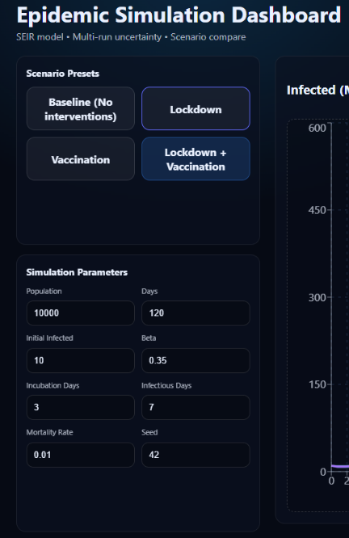
- Responsive UI dashboard layout on a smaller screen

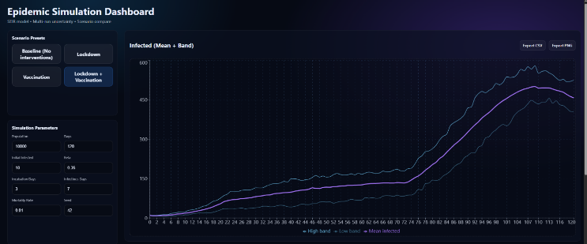
- Full Epidemic Simulation Dashboard with the multi-run infected uncertainty plot

Table II shows a sample of the simulation results, including key measures such as the average number of infected individuals and the upper and lower uncertainty limits for selected days. It gives a brief overview of how the model behaves and how results vary across multiple stochastic simulation runs.

Reproducibility and Packaging
To make the project mentor-ready and easy to share across machines, we package the simulator as a two-part system (backend + frontend) with a minimal, reproducible setup.
- The Backend (FastAPI): pinned dependencies inside requirements.txt and installed in separated Python environment. Uvicorn starts the service and exposes the endpoint for quick verification [14].
- The Frontend (React): Npm manages the dependencies. The dashboard reads the URL for the API from the environment configuration (.env.example), which allows others to run locally or remotely without code changes.
Project documentation includes a README with an overview, how-to-run steps, screenshots of the UI, and a short architecture diagram describing the data flow between the UI and API.

Discussion
The developed epidemic simulation, configurable via the dashboard, showcases how technical design and implementation of uncertainty visualization can improve the opportunities for modeling tools for epidemics. Main features include the separation capability of the simulation engine, backend, and frontend. This feature ensures that improvements on one layer, such as adding new policies or compartments, do not modify the presentation layer.
Having the possibility for multiple runs with distinct seeds and aggregating results in quantile bands, the user can obtain a real image of the epidemic trajectory possibilities. This corresponds to the recent literature that are characterized with intervals or confidence bands for forecasting epidemics [15]. This kind of visualization may be very beneficial for teaching and investigating scenarios for rapid comparisons when there is high uncertainty in parameters or limitations to data.
This type of configuration-driven engine improves extensibility and reproduction capabilities. Specific configuration enables many assumptions on compartment manners, stochastic seeds, and timing in interventions, making it easy to share, archive, and reproduce various experiments. For growing purposes and improvements of computational epidemiology, it is essential for the models to be transparent for communication and policy support.
These types of functions may also provide additional help when implemented into already developed eHealth information systems, specifically by improving transparency, decision support, and adaptation of the system. This corresponds with other findings on user satisfaction [16], system privacy and security [17], and delivery of digital healthcare services [18].
However, this study comes with limitations that remain. First, the SEIR model was structured without a contact network, age-structured, or spatial diversity. Numerous real epidemics have characteristics that cannot be thoroughly presented by uniform compartmental models, dynamic contact patterns, and spatial spreading that can affect the spreading and intervening effects of the disease.
Second, the representations of the interventions, such as fixed transmission increments for periods in lockdowns, or ordinary daily rates for immunization, are favored. In real interventions there are variable assessments, effect delays, or feedback of the epidemic states. Implementing more subtle models for policy, like manner response functionalities or time-dependent docility, may improve precision.
Third, although the multi-run stochastic aggregation incorporates variability from processes that are random, it does not take into account the uncertainty parameters like transmission rate, period of incubation, or efectivness from vacinations.
- Sample simulation results (multi-run summary statistics)
Metric | Baseline | Lockdown | Vaccination
Peak infected (Mean) | 1500 | 900 | 1100
Peak day | 62 | 75 | 70
Bandwidth (High–Low at peak) | 400 | 250 | 300

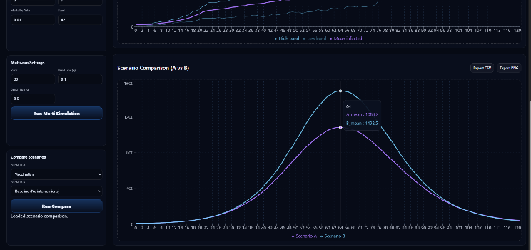
- Scenario Comparison chart (A vs B), allowing direct comparison of two intervention presets by showing their infected trajectories on the same timeline

More advanced methods, like Monte Carlo sequential or Bayesian calibration, would be more beneficial for adequate uncertainty parameter quantification that could improve the current approach [15]. Future improvements include adding more intervention types, richer reporting/export features, and validation workflows that compare simulated trajectories against real-world data while preserving reproducibility. Incorporate more sections (for example: asymptomatic vs. symptomatic, hospitalized, etc.), techniques to read in data for calibration of the engine against observed data. Even with the identified weaknesses in the simulation, further studies should be directed at enhancing the realism of the models by using more sophisticated assumptions, perfecting the intervention methods, and applying epidemiologic data from real-life situations. Further work is required to consider validation with real-world data, comparison of the deterministic and stochastic versions of the approach, justification of defaults used in parameters, and quantification of uncertainty effects.

Conclusion
A reproducible, config-driven SEIR simulation system with intervention modeling, multi-run uncertainty bands, and scenario comparison through a FastAPI backend and a React visualization layer was delivered in this research. This configuration-driven dashboard presents a reusable and flexible tool for exploring various epidemic scenarios. The separation of concerns (engine/API/UI) makes the project easy to scale (e.g., larger populations) and to extend with additional compartments or policies without redesign. This research fills in gaps between practical support tools for making decisions and epidemiological model research by joining web services, modular engines, and an interactive GUI that would contribute to a transparent and extensive epidemic workflow analysis.

References
- F. Mirsaeedi, M. Sheikhalishahi, M. Mohammadi, A. Pirayesh, and D. Ivanov, “Compartmental models in epidemiology: bridging the gap with operations research for enhanced epidemic control,” Annals of Operations Research, vol. 357, no. 2–3, pp. 1021–1078, Oct. 2025, doi: 10.1007/s10479-025-06893-1.
- ‌E. A. Rozan, M. N. Kuperman, and S. Bouzat, “The importance of the incubation time distribution in compartmental epidemiological models,” Physica a Statistical Mechanics and Its Applications, vol. 650, p. 129998, Jul. 2024, doi: 10.1016/j.physa.2024.129998.
- W.-H. Hu, H.-M. Sun, Y.-Y. Wei, and Y.-T. Hao, “Global infectious disease early warning models: An updated review and lessons from the COVID-19 pandemic,” Infectious Disease Modelling, vol. 10, no. 2, pp. 410–422, Dec. 2024, doi: 10.1016/j.idm.2024.12.001.
- M. T. Sofonea, S. Cauchemez, and P.-Y. Boëlle, “Epidemic models: why and how to use them,” Anaesthesia Critical Care & Pain Medicine, vol. 41, no. 2, p. 101048, Feb. 2022.
- J. Corbin et al., “A flurry of infectious disease modeling tools during the COVID-19 pandemic, considerations for future selection,” Pathogens, vol. 14, no. 9, p. 877, Sep. 2025.
- W. O. Kermack and A. G. McKendrick, “A contribution to the mathematical theory of epidemics,” Proceedings of the Royal Society A, vol. 115, no. 772, pp. 700–721, 1927.
- H. W. Hethcote, “The mathematics of infectious diseases,” SIAM Review, vol. 42, no. 4, pp. 599–653, 2000.
- O. Diekmann, J. A. P. Heesterbeek, and T. Britton, Mathematical Tools for Understanding Infectious Disease Dynamics. Princeton, NJ, USA: Princeton University Press, 2013.
- C. C. Kerr et al., “Covasim: An agent-based model of COVID-19 dynamics and interventions,” PLoS Computational Biology, vol. 17, no. 7, p. e1009149, 2021, doi: 10.1371/journal.pcbi.1009149.
- S. Ramírez, “FastAPI,” 2018. [Online]. Available: https://fastapi.tiangolo.com/
- “DevDocs — FastAPI documentation.” https://devdocs.io/fastapi/
- “Recharts.” https://recharts.github.io/
- “Quick start – react.” https://react.dev/learn
- “Uvicorn.” https://uvicorn.dev/
- D. S. Silk, V. E. Bowman, D. Semochkina, U. Dalrymple, and D. C. Woods, “Uncertainty quantification for epidemiological forecasts of COVID-19 through combinations of model predictions,” Statistical Methods in Medical Research, vol. 31, no. 9, pp. 1778–1789, Jul. 2022, doi: 10.1177/09622802221109523.
- V. Denkovski, G. Gavrilov, I. Stojmenovska, and V. Radevski, “Evaluating Physicians’ Satisfaction with Using eHealth System for Managing Patients in Primary and Secondary Care,” EAI Endorsed Transactions on Pervasive Health and Technology, vol. 11, Feb. 2025, doi: 10.4108/eetpht.11.4157.
- V. Denkovski, I. Stojmenovska, G. Gavrilov, V. Radevski, and V. Trajkovik, “Exploring current challenges on security and privacy in an operational eHealth information system,” Advances in Science Technology and Engineering Systems Journal, vol. 9, no. 2, pp. 45–53, Apr. 2024, doi: 10.25046/aj090206.
- V. Denkovski and G. Gavrilov, “E-appointments at primary care physicians during Covid-19 pandemic: viewpoint and satisfaction of medical consumers,” EAI Endorsed Transactions on Pervasive Health and Technology, vol. 8, no. 31, p. e2, May 2022, doi: 10.4108/eetpht.v8i31.1129.

